

Foundations of Programming

Assignment No.: 21
PROBLEM STATEMENT: Write a C program to copy contents of one file to another using file handling.

OBJECTIVE:

- To understand the concept of file handling in the C programming language.
- To learn how to read data from a file and write data into another file.
- To implement file copy operation using standard file handling functions.

THEORY:
File handling in the C programming language allows programs to store and retrieve data from files. Files are handled using file pointers and standard functions such as fopen(), fclose(), fgetc(), and fputc().

In this program, the source file is opened in read mode, and the destination file is opened in write mode. The program reads characters from the source file one by one using fgetc() and writes them to the destination file using fputc(). This process continues until the end of the file (EOF) is reached. Thus, the contents of the source file are successfully copied into the destination file.
PLATFORM: Linux
Algorithm:
- Start
- Declare variables
- Create and write to source file
- Open files for copying
- Copy contents from source to destination
- Close both files
- Print "File copied successfully."

- Open "destination.txt" in read mode
- Print "Destination file will contain:"
- Read each character using fgetc() until EOF:
  - Display character using putchar()
- Close destination file
- Stop
Code:
#include <stdio.h>
int main()
{
FILE *source,*destination;
char ch;
source=fopen("source.txt","w");
fprintf(source,"Hello World\n");
fprintf(source,"Welcome to Pune\n");
fclose(source);
source=fopen("source.txt","r");
destination=fopen("destination.txt","w");
while ((ch=fgetc(source))!=EOF)
{
fputc(ch,destination);
}
fclose(source);
fclose(destination);
printf("File copied successfully.\n");
destination=fopen("destination.txt","r");
printf("Destination file will contain:\n");
while ((ch=fgetc(destination))!=EOF)
{
putchar(ch);
}
fclose(destination);
}

INPUT: A source file containing text data.

OUTPUT: Contents of the source file copied into another file.
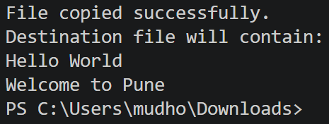

FAQs:
- What is file handling in C programming, and why is it important?
- What is the purpose of fopen() and fclose() functions in file operations?
- How does the program detect the end of a file using EOF?

